Program 1:

import java.util.Scanner;

public class week1_1 {

public static void main(String[] args) {

Scanner sc = new Scanner(System.in);

int t = sc.nextInt();

while (t-- > 0) {

try{

long num = sc.nextLong();

System.out.println(num + " can be fitted in:");

if (num >= Byte.MIN_VALUE && num <= Byte.MAX_VALUE) {

System.out.println("* byte");

}

if (num >= Short.MIN_VALUE && num <= Short.MAX_VALUE) {

System.out.println("* short");

}

if (num >= Integer.MIN_VALUE && num <= Integer.MAX_VALUE) {

System.out.println("* int");

}

if (num >= Long.MIN_VALUE && num <= Long.MAX_VALUE) {

System.out.println("* long");

}

}

catch(Exception e){

String a=sc.nextLine();

System.out.println(a+" can&#39;t be fitted anywhere.");

}

}

}

}

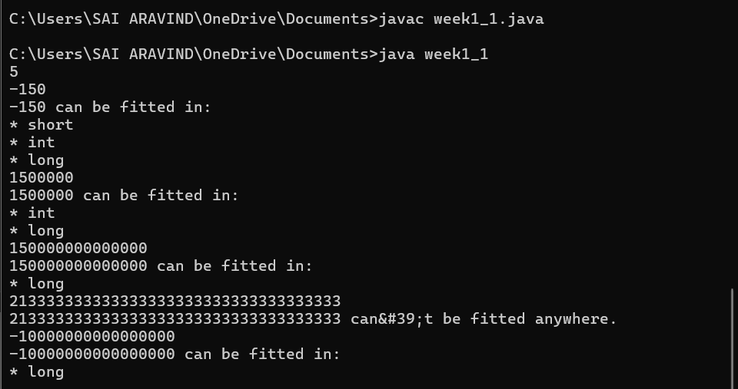

Program 2:

import java.util.*;

public class week1_2

{

public static void main(String args[])

{

Scanner sc = new Scanner(System.in);

int cents = sc.nextInt();

double cent = cents;

double dollars = cent/100;

System.out.printf("%.2f", dollars);

}

}

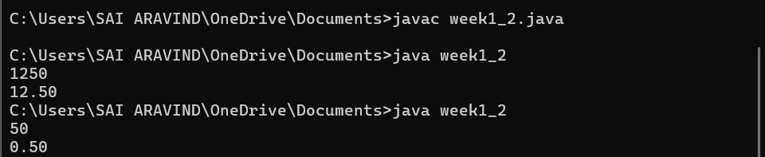

Program 3:

import java.util.*;

public class week1_3

{

public static void main(String args[])

{

Scanner sc = new Scanner(System.in);

double score = sc.nextDouble();

int Score = (int) score;

System.out.println(Score);

}

}

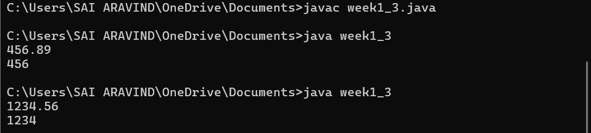

Program 4:

import java.util.*;

public class week1_4

{

public static void main(String[] args) {

Scanner sc = new Scanner(System.in);

int salary = sc.nextInt();

double interest = sc.nextDouble();

double newSalary = salary+(salary * (interest*0.01));

System.out.println(newSalary);

}

}

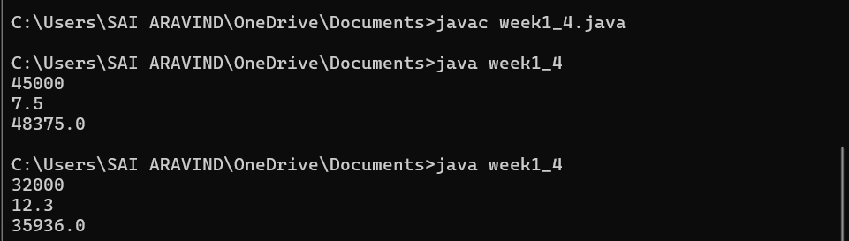

Program 5

import java.util.*;

public class week1_5

{

public static void main(String args[])

{

Scanner sc = new Scanner(System.in);

int num = sc.nextInt();

int rem = 0, rev = 0;

while(num!=0)

{

rem = num%10;

rev = rev*10 + rem;

num /= 10;

}

System.out.println(rev);

}

}

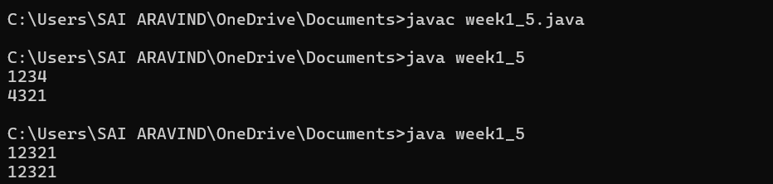

Program 6

import java.util.Scanner;

public class week1_6

{

public static void main(String[] args)

{

Scanner sc = new Scanner(System.in);

int n = sc.nextInt();

for (int i = 1; i <= n; i++)

{

for (int j = i; j < n; j++)

System.out.print(" ");

for (int k = 1; k <= (2 * i - 1); k++)

System.out.print("*");

System.out.println();

}

for (int i = n - 1; i >= 1; i--) {

for (int j = n; j > i; j--)

System.out.print(" ");

for (int k = 1; k <= (2 * i - 1); k++)

System.out.print("*");

System.out.println();

}

}

}

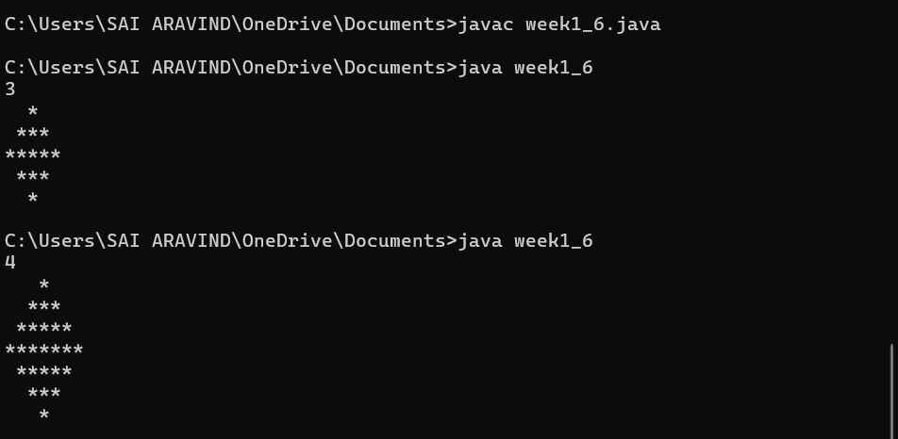

Program 7:

import java.util.Scanner;

public class week1_7{

public static void main(String[] args) {

Scanner sc = new Scanner(System.in);

int n = sc.nextInt();

sc.close();

int[][] p = new int[n][];

for (int i = 0; i < n; i++) {

p[i] = new int[i + 1];

p[i][0] = 1;

p[i][i] = 1;

for (int j = 1; j < i; j++) {

p[i][j] = p[i - 1][j - 1] + p[i - 1][j];

}

}

for (int i = 0; i < n; i++) {

int spaces = (n - i - 1);

for (int j = 0; j < spaces; j++) {

System.out.print(" ");

}

for (int j = 0; j <= i; j++) {

System.out.print(p[i][j] + " ");

}

System.out.println();

}

for (int i = n - 2; i >= 0; i--) {

int spaces = (n - i - 1);

for (int j = 0; j < spaces; j++) {

System.out.print(" ");

}

for (int j = 0; j <= i; j++) {

System.out.print(p[i][j] + " ");

}

System.out.println();

}

}

}

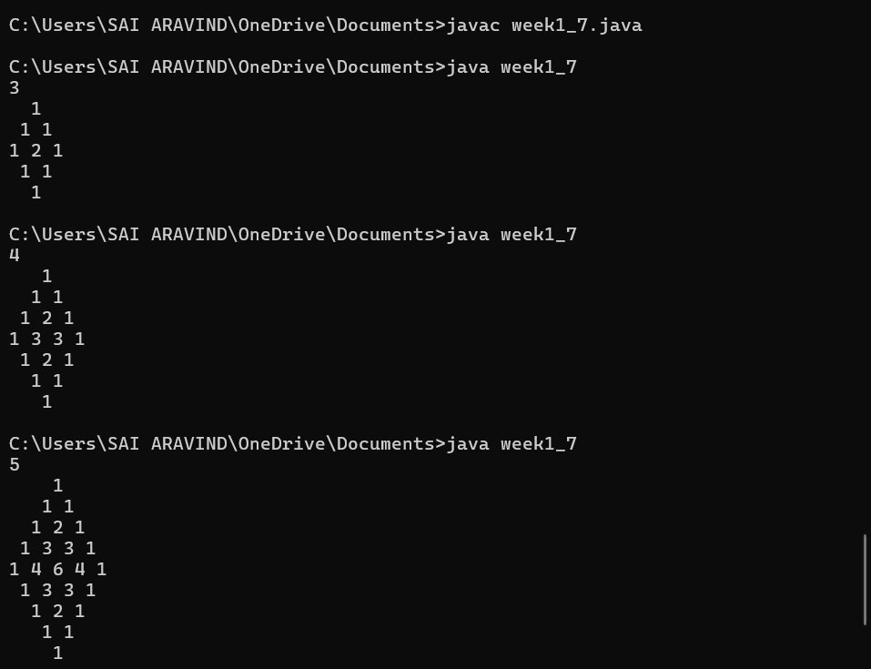

Program 8:

import java.util.*;

public class week1_8

{

public static void main(String args[])

{

Scanner sc = new Scanner(System.in);

int q = sc.nextInt();

while(q>0)

{

int a = sc.nextInt();

int b = sc.nextInt();

int n = sc.nextInt();

int d = 0;

while(d<=n)

{

int sum = a;

for(int i=0; i<d; i++)

sum += Math.pow(2, i)*b;

System.out.print(sum + " ");

d++;

}

q--;

}

}

}

